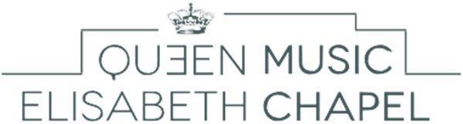
Music Chapel

Voice Audition - Application form

To be sent to: audition@musicchapel.org

Personal data

Address

Last name:

Residence (Street, No.):

First name:

Date of birth:

Postal code:

City:

Place of birth:

Country:

Nationality:

Telephone:
Mobile:

E-mail:

Program Requirements

Pre-selection video
- An aria by W.A. Mozart
- A French Melody or a German Lied
- One opera aria of your choice
Live Audition
- A French song
- A German Lied
- An aria by W. A. Mozart
- An aria from an opera in Italian
- Any one piece of your own choice

Pre-selection: DVD Program – YouTube link :

Composer (full name) Title of piece, opus

1

2

3

Live Audition

Would you like to be accompanied by our official pianist?

Yes

No - Name of your pianist:

Composer (full name) Title of piece, opus

1

2

3

4

5

How have you heard of the Queen Elisabeth Music Chapel?

Our website
Advertisement for the auditions in a magazine
Professor:
Poster in your conservatory
International Queen Elisabeth Competition
Internet
Former or current artists in residence at the Music Chapel
Other:

