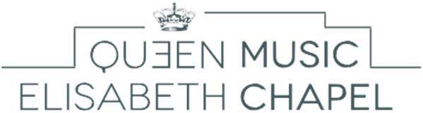
Music Chapel

Violin Audition - Application form

To be sent to: audition@musicchapel.org

Personal data

Address

Last name:

Residence (Street, No.):

First name:

Date of birth:

Postal code:

City:

Place of birth:

Country:

Nationality:

Telephone:
Mobile:

E-mail:

Program Requirements

Pre-selection video
- A. Mozart: a concerto for violin, 1st movement
- S. Bach: Adagio (Grave) & Fugue
- One virtuoso piece of your choice
Live Audition
For Outstanding Young Musicians
- Adagio and fugue by J.S. Bach
- One Movement of a concerto by W.A. Mozart
- Three pieces of your choice
For Artist Diploma
- One sonata or partita for solo violin by J.S. Bach
- Any concerto by W.A. Mozart
- A piece of works by N. Paganini, H. Vieuxtemps, H. Wieniawski or E. Ysaÿe
- A piece of your choice (between 20 and 25 minutes)

Pre-selection: DVD Program – YouTube link :

Composer (full name) Title of piece, opus

1

2

3

Live Audition

Would you like to be accompanied by our official pianist?

Yes

No - Name of your pianist:

Composer (full name) Title of piece, opus

1

2

3

4

5

How have you heard of the Queen Elisabeth Music Chapel?

Our website
Advertisement for the auditions in a magazine
Professor:
Poster in your conservatory
International Queen Elisabeth Competition
Internet
Former or current artists in residence at the Music Chapel
Other:

