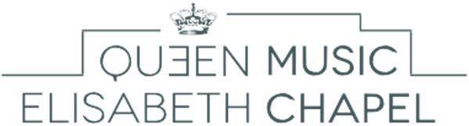
Music Chapel

Chamber Music Audition - Application form
Please fill in one sheet per person.

To be sent to: audition@musicchapel.org

Personal data

Address

Last name:

Residence (Street, No.):

First name:

Date of birth:

Postal code:

City:

Place of birth:

Country:

Nationality:

Telephone:
Mobile:

E-mail:
Program Requirements

Pre-selection video
- 1st movement of any piece by W.A. Mozart or
J. Haydn of your choice
- 1st movement of any piece from the 19th century
- 1st movement of any piece from the 20th century
Live Audition
- A piece from the Classical period (ALL movements)
- A piece of your own choice (ALL movements)

Pre-selection: DVD Program – YouTube link :

Composer (full name) Title of piece, opus

1

2

3

Live Audition
Composer (full name) Title of piece, opus

1

2

How have you heard of the Queen Elisabeth Music Chapel?

Our website
Advertisement for the auditions in a magazine
Professor:
Poster in your conservatory
International Queen Elisabeth Competition
Internet
Former or current artists in residence at the Music Chapel
Other:

