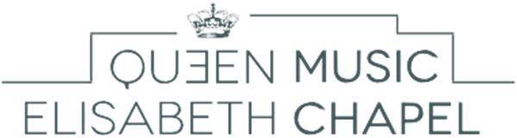
Music Chapel

Cello Audition - Application form

To be sent to: audition@musicchapel.org

Personal data

Address

Last name:

Residence (Street, No.):

First name:

Date of birth:

Postal code:

City:

Place of birth:

Country:

Nationality:

Telephone:
Mobile:

E-mail:

Program Requirements

Pre-selection video
- Prelude from a Suite by J.S. Bach
- A movement from a concerto or a romantic sonata
of your choice
Live Audition
For Outstanding Young Musicians
- Prelude from a Suite by J.S. Bach
- 1st movement of a concerto by J. Haydn, C.P.E. Bach or Boccherini
- A piece of your choice
For Artist Diploma
- Prelude from a Suite by J.S. Bach
- 1st movement of a concerto by J. Haydn, C.P.E. Bach or Boccherini
- A sonata or a concerto (ALL movements) or any piece of equal level from the 19th or the 20th
- A piece of your choice

Pre-selection: DVD Program – YouTube link :

Composer (full name) Title of piece, opus

1

2

Live Audition

Would you like to be accompanied by our official pianist?

Yes

No - Name of your pianist:

Composer (full name) Title of piece, opus

1

2

3

4

How have you heard of the Queen Elisabeth Music Chapel?

Our website
Advertisement for the auditions in a magazine
Professor:
Poster in your conservatory
International Queen Elisabeth Competition
Internet
Former or current artists in residence at the Music Chapel
Other:

